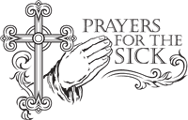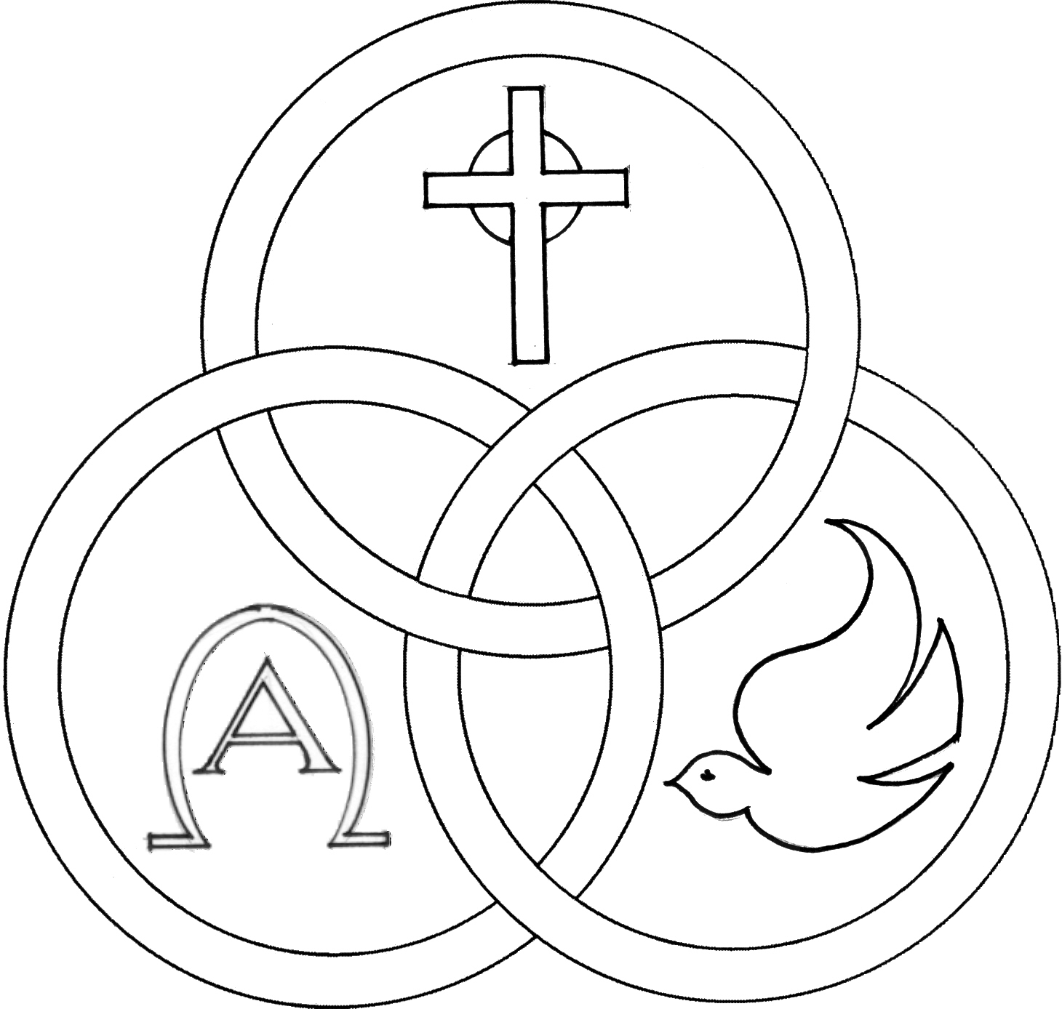**Parish of the Holy Trinity** *Roman Catholic Church*

951Stafford Road

Fall River, Massachusetts

[**www.holytrinityfallriver.com**](http://www.holytrinityfallriver.com)

***Fourth Sunday of Lent***

**Saturday 3/29 4th Sunday of Lent**

4:00 pm Michael J. Tremblay*(by Wife & Family)*

**Sunday 3/30 4th Sunday of Lent**

8:30 am Odelia Andrade7th Anniversary*(by Family)*

10:30 am Doris Berube 105th Birthday Remembrance

*(by Roger)*

**Monday 3/31 Lenten Weekday**

8:30 am Thomas & Gertrude Mercer

**Tuesday** **4/1 Lenten Weekday**

8:30 am Raymond Mello & Mello Family

**Wednesday 4/2 Lenten Weekday**

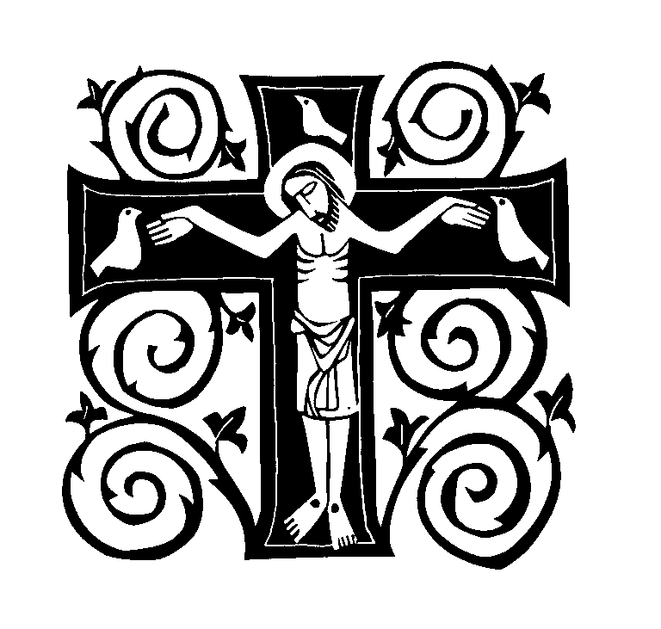8:30 am For the People *of our parish*

**Thursday 4/3 Lenten Weekday**

8:30 am Joe, Henry & Carol Medeiros *(by Family)*

**Saturday 4/5 5th Sunday of Lent**

4:00 pmDaniel S. Silvia *(by Wife Gerrie)*

**Sunday 4/6 5th Sunday of Lent**

8:30 amHazel Lynn 4th Anniversary *(by Family)*

10:30 am Maria deJesus & Antonio Gervasio  *(by Family)*

ISCBC005 **Blessed Sacrament Sanctuary Lamp:**

*Given this week in memory of*

Michael J. Tremblay

By Wife & Family

**CSOFT003 Week of 3/23/25**

**Budget $4,314.35**

**Fuel $2,086.00**

**Yellow registration forms** are available on the tablesinside Church, near each of the entrances. Please drop them into the collection basket at Mass and **introduce yourself to Father Oliveira** after Mass or call the parish office for an appointment. **We** **hope that you feel very much at home!**

**PRAY FOR THE SICK OF OUR PARISH** and our families especially for those in hospitals, rehabilitation centers, nursing facilities and the homebound. Pray for all those who are undergoing medical treatments at this time.

**THE CATHOLIC RELIEF SERVICES** collection will be taken up as the second collection this weekend. This collection supports the work of CRS in their direct assistance to the thousands of suffering people who are in tremendous need in so many countries throughout the world. Thank you for your generosity for those in need. Please remember the work of CRS in your prayers.

**CITY-WIDE 2025 LENTEN MISSION “The Fire of Love Rekindles Our Hope” is scheduled for March 31st thru April 3rd and will be offered by Fr. Stan Fortuna, CFR. Franciscan friar, musician and speaker.**

**Daytime Sessions** at St. Mary’s Cathedral 327 Second St. Fall River, MA 02721

Confessions: 11:15am-11:45am

Mass and Mission Talk: 12:00pm

**Evening Sessions** at Bishop Connolly High School 373 Elsbree St. Fall River, MA 02720

Confessions: 6:00pm-6:45pm

Mass and Mission Talk: 7:00pm

**All are most welcome!**

**EASTER FLOWERS** – We hope to have the Church beautifully decorated for Easter in memory of our beloved deceased. Please utilize the Easter Flower envelope found in our special Lenten/Easter mailing which you will be receiving by mail. On the envelope please indicate the name(s) of those you wish to remember. The envelope may be brought to Church or sent to our parish office at your earliest convenience. **All names received by Sunday, April 13th** will be published in a memorial bulletin for Easter**. Thank you so very much** for helping us to decorate our beautiful Church for the most important celebration of our faith!

**THE RELIGIOUS EDUCATION OFFICE:** Classes will be held Sunday in Church for the sacramental years and on-line for grades 3 thru 7.

**THE SACRAMENT of CONFIRMATION CONGRATULATIONS to Blake Almeida, Brandon Almeida, Meghan Bailey, Leandro Belicio, Kamryn Boucher, Juliana Branco, Matthew Brett, Owen Cabral, Hannah Choquette, Owen Doyle, Aiden Dussault, Sophia Esteves, Siena Fragata, James Geiger, Chase Perez-Hemling, Connor Perez-Hemling, Maria Henrique, Emma LaFontaine, Enzo Lage, Olivia Leger, Cayden Moniz, Kherington Moniz, Sophia Oliver, Olivia Parker, Benjamin Ponte, Hayle Rosas, Parker Sardinha, Savanna Soares, Thomas Sullivan IV, Kylie Travis and Luke Viera** who received the Sacrament of Confirmation this past Tuesday, here at Holy Trinity. Welcome to all of you who completed your Sacrament of Initiation into the Church.

**THANK YOU** to Bishop da Cunha who conferred the Sacrament on our students. Thanks also to Vicky & Michael Robertson for preparing the newly confirmed for the Sacrament of Confirmation. You did a great job!

***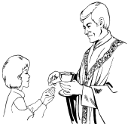*THE SACRAMENT OF THE FIRST EUCHARIST** will be celebrated here in our parish on Sunday, May 4th. Please keep in your prayers the children who will be making their First Communion.

**LENTEN PRAYER AND RELECTION** During the next few weeks of Lent you are invited to join in prayer and reflection with Fr. Bob via the following online presentations that are prerecorded for your convenience.

**Wednesday:  The Gift we are and the Gift we are called to Be.**

**Friday: Stations of the Cross**

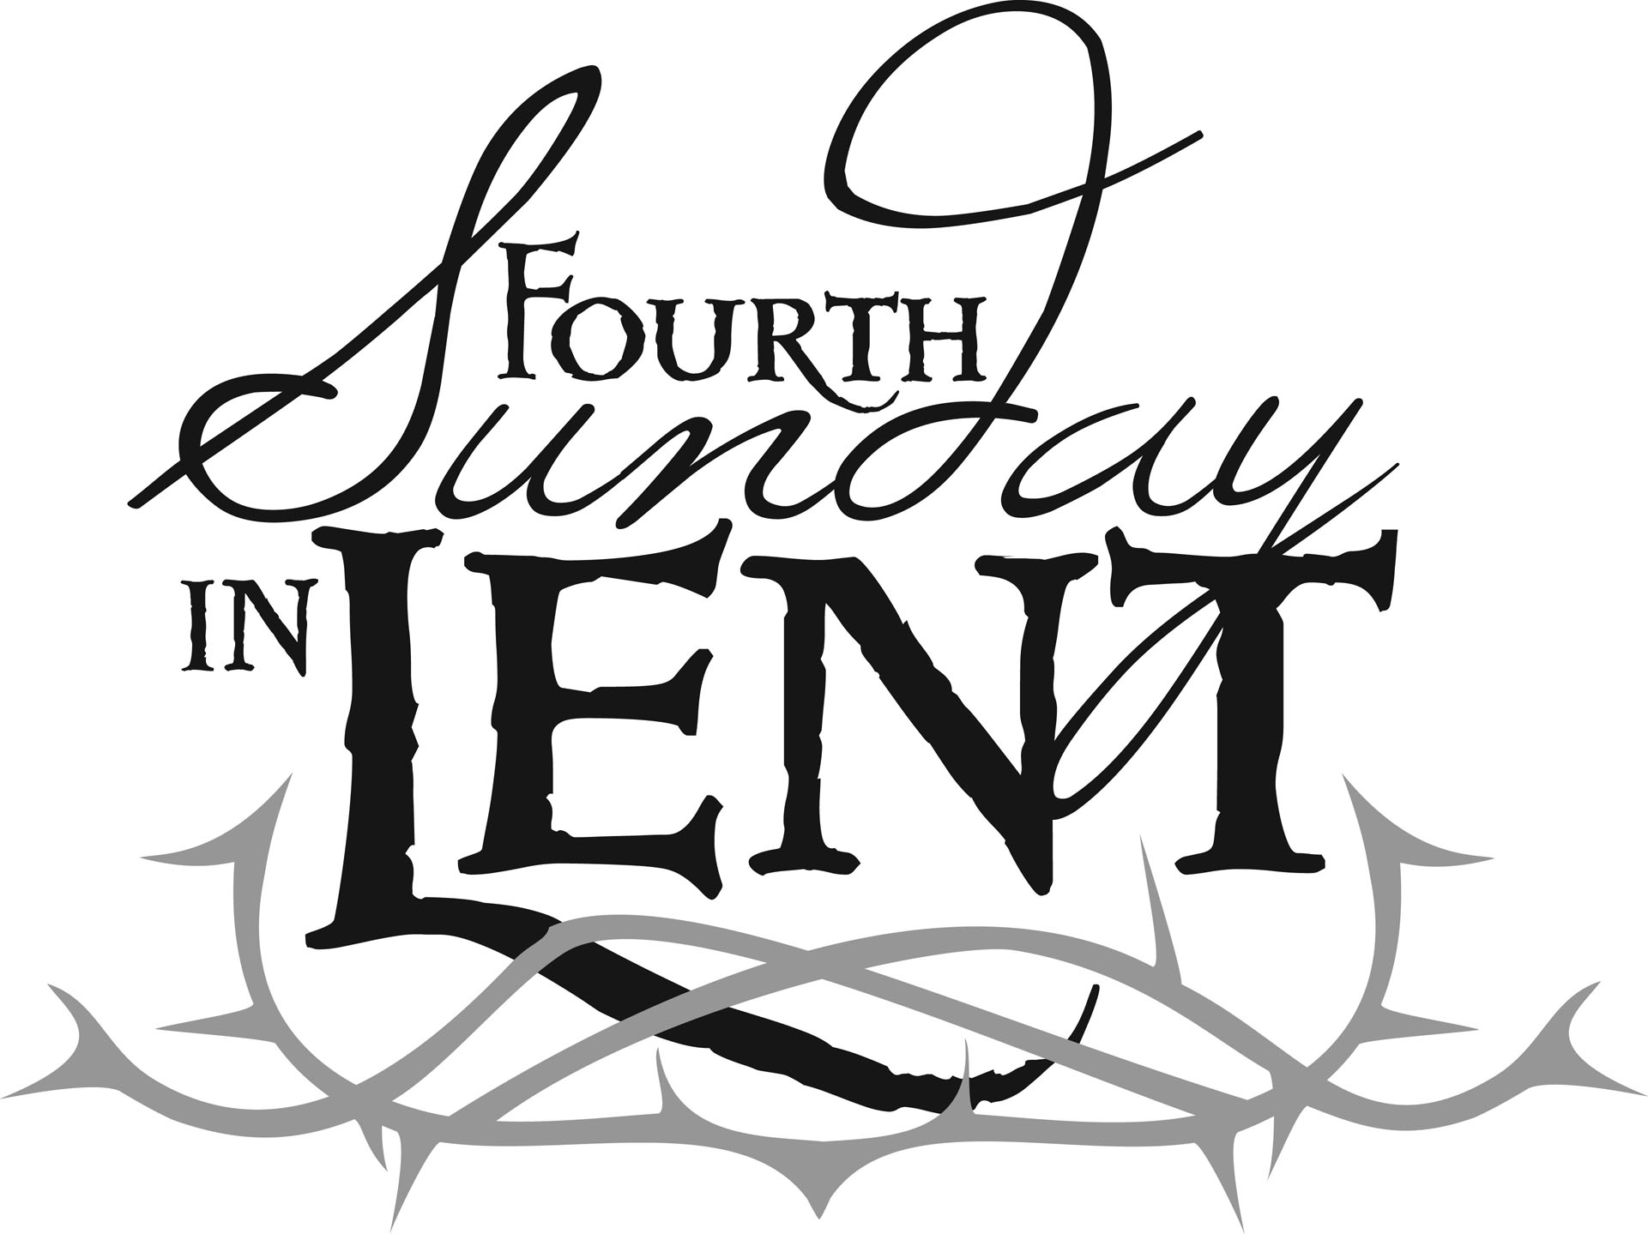**Sunday: Eucharist Reflection and Family Catechesis**

**Daily: Homily and Scripture Reflections.**

**Presentation can be accessed by the following sites:**

**FACEBOOK: Holy Trinity Parish Fall River MA**

**Parish Web:**[**www.holytrinityparishfallriverma.com**](http://www.holytrinityparishfallriverma.com/)

**THIS WEEK’S REFLECTION:** The gospels this week make it very clear toward the end of the week that Jesus faced opposition that couldn't accept who he is. We see that Jesus comes to lay down his life that we might live. So, this week of Lent is an important time for us to ask ourselves if there are any parts of our hearts, any of our patterns, that oppose Jesus and his desire to give us life. This kind of honesty can transform our lives. It can allow the grace of God to bring reconciliation and healing we might not have imagined.

Even if it hasn't been easy to get really engaged with Lent so far, we can still make a beginning, even now. The key is openness and desire. If we can feel any attraction, any sign that the Lord is possibly drawing us, then the Lord can work with us - no matter what resistance or fear we might also be experiencing. All we have to do is act out of these desires and simply ask the Lord for the grace to help us be more honest and more open to what he is offering us. For example, we can ask for the grace to examine our consciences more thoroughly. We could try a different approach to facing any resistance we might have to the Lord's working in us. We might not commit the big sins, but we may not have examined what we fail to do. Who am I failing to love, to forgive, to be generous to? From whom am I withholding affection, care, reconciliation? Where can I live more honestly, with more integrity? How might I proactively change my own personal patterns of escape with patterns of care for others?

It is a time of grace when we can experience moments of “recognition,” or self-understanding. But it is *not* a grace to beat up on ourselves or become self-absorbed in our own guilt. It *is* grace to feel grateful to the Lord for showing us obstacles to the life he is offering us. It is grace to feel our spirits lighten as we feel drawn to greater freedom and peace. It is incredible grace when we are drawn to celebrate the Sacrament of Reconciliation. This week, let us give thanks to the Lord who deeply desires our greater freedom and joy. As we go to bed each night, let us thank the Lord for what we saw that day and renew our desires for the next day of grace.