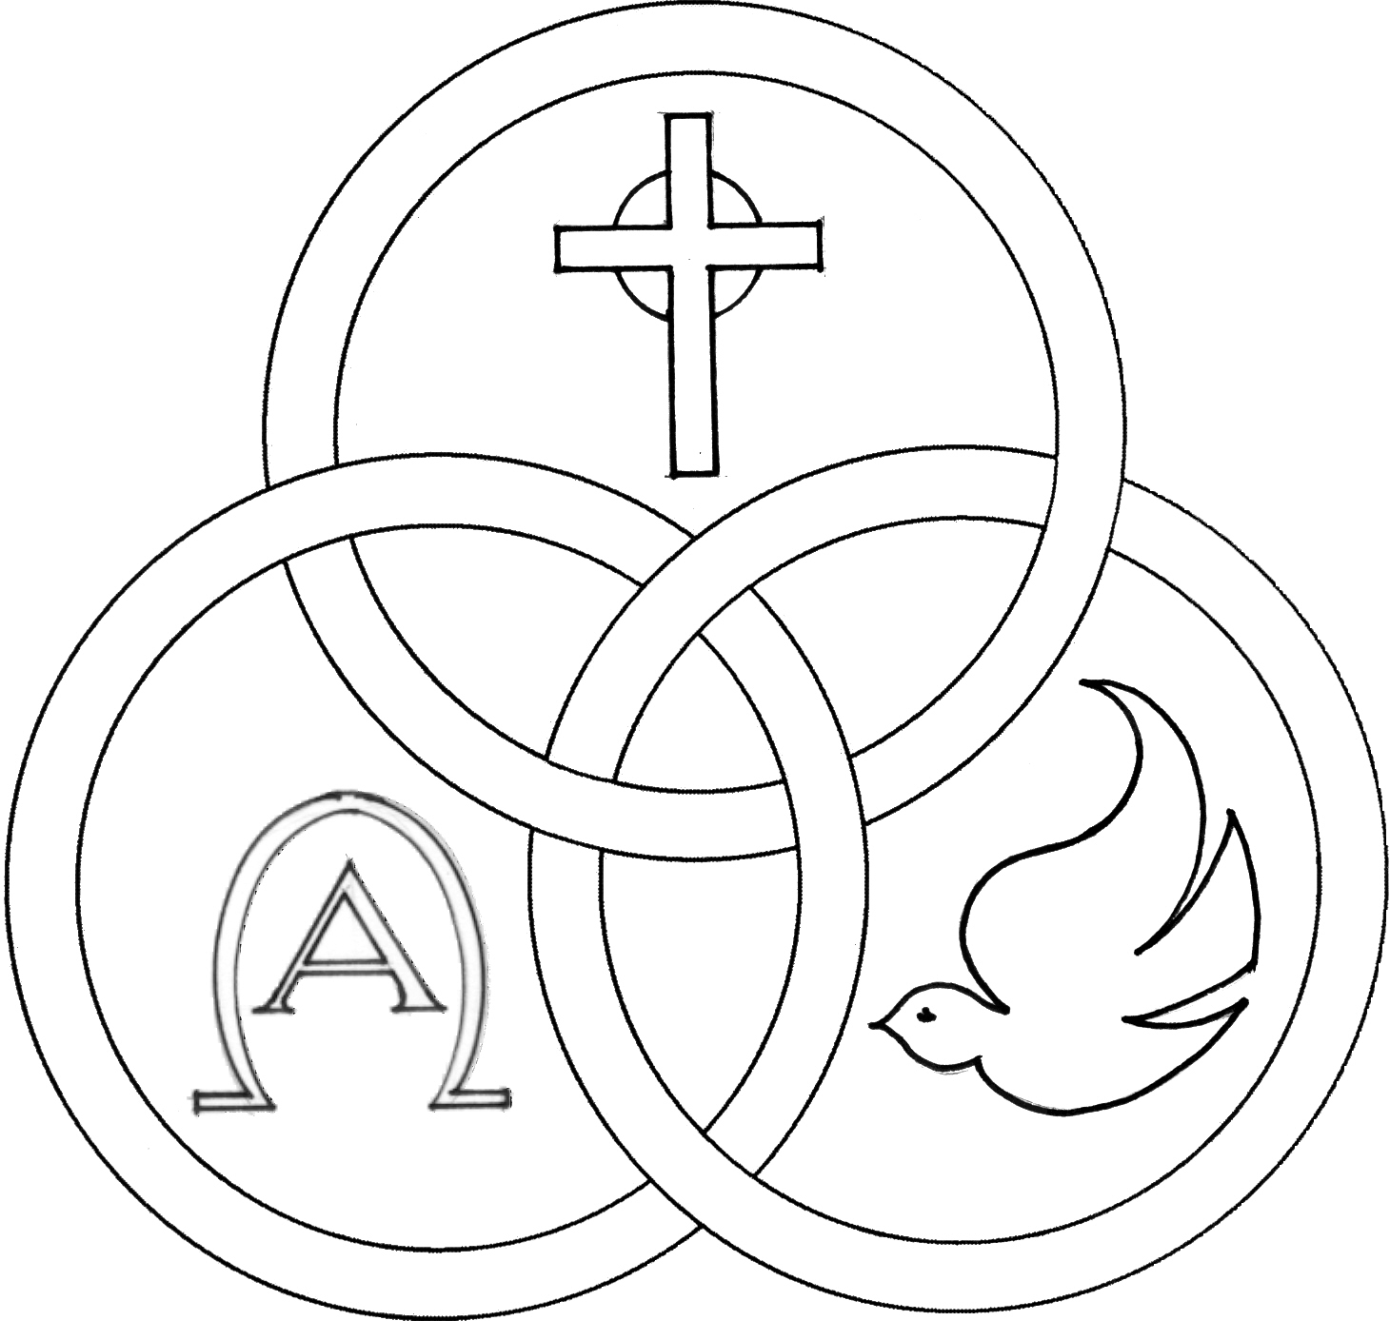**Parish of the Holy Trinity** *Roman Catholic Church*

951Stafford Road

Fall River, Massachusetts

[**www.holytrinityfallriver.com**](http://www.holytrinityfallriver.com)

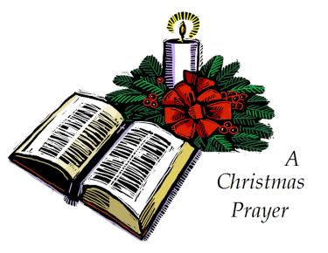

***Feast: Baptism of the Lord***

**Saturday 1/11 Feast: Baptism of the Lord**

4:00 pm Barbara & William O’Neil & Karen Costa *(by Bill)*

**Sunday 1/12 Feast: Baptism of the Lord**

8:30 am James Arruda *(by Jan)*

10:30 am Antoinette Marceline *(by Family)*

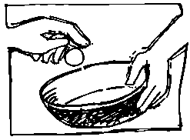

**Monday 1/13 Weekday**

8:30 am Vivian Dion *(by son Edward)*

**Tuesday** **1/14 Weekday**

8:30 am Joseph & Edward Carreiro *(by Lucille)*

**Wednesday 1/15 Weekday**

8:30 am Maria deJeusu & Antonio Gervasio

*(by Family)*

**Thursday 1/16 Weekday**

8:30 am For the People *of our parish*

**Saturday 1/18 2nd Sunday in Ordinary Time**

4:00 pmFrancis Arruda *(by Jan & Mike)*

**Sunday 1/19 2nd Sunday in Ordinary Time**

8:30 amCanuel & Levesque Families *(by Anna)*

10:30 am Robert Chouinard *(by Wife & Family)*

ISCBC005 **Blessed Sacrament Sanctuary Lamp:**

*Given this week in memory of*

Augusta Andrade

**CSOFT003 Week of 1/5/25**

**Budget $4,001.00**

**Snow $2,060.00**

**300**

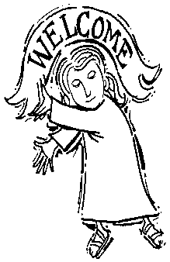**Yellow registration forms** are available on the tablesinside Church, near each of the entrances. Please drop them into the collection basket at Mass and **introduce yourself to Father Oliveira** after Mass or call the parish office for an appointment. **We** **hope that you feel very much at home!**

**FROM THE PASTOR** THANK YOU to the many people for your Christmas wishes and blessings and for the cards, gifts and goodies. They were greatly appreciated.

**THANKS TO ALL** our parishioners and friends who generously donated $7,683.00 for the Christmas collection for our parish.Thank you for your Christmas gift to our parish and thank you for your faithful support throughout the year.

**THE SECOND COLLECTION**

this weekend is the monthly collection for maintenance and expense reduction for our parish. Thank you for all your generosity.

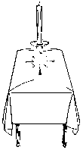**PLEASE REMEMBER IN YOUR PRAYERS Michele Blanchette and Madeline Wilding** whose funerals were celebrated in our parish. We extend our prayerful support to their families and friends. *May their souls and the souls of all the faithful departed, through the Mercy of God rest in peace. Amen.*

**THE CHRISTMAS SEASON** will conclude this Sunday, January 12th, the feast of the Baptism of the Lord**.** May our celebration of Christ’s birth enable us to welcome the God who dwells among us!

**FOR ALL THOSE WHO WOULD LIKE** a plant from our Christmas display, they will be available after the 10:30am Mass THIS Sunday. Plants will be distributed right after Mass on a first come/ first serve basis. **For reasons of good order and fairness we ask that all those who would like a plant, *please be seated in the pews* directly in front of the Lectern and a plant will be brought to you.**

**RELIGIOUS EDUCATION**

Religious Formation Classes. Grades 3-7 will continue to be presented online via FACEBOOK  at Holy Trinity Parish Fall River.  First Communion (grades 1-2) and Confirmation classes (grades 8-9) will be held in personin the parish church and parish center following the 8:30 Sunday liturgy. Kindly note we do require in writing baptismal information for our students. As in the past class notes and Sunday preparation materials will be forwarded to each student via email.



**Christmas Flower Memorial**

*Also included in loving memory of:*

Amiot, Phyllis

Brouillard, Jeffrey

Botelho, Mary

**THANK YOU** A VERY SPECIAL THANKSto our women’s guild who has given a $3,500.00 gift to our parish. With the fundraisers our guild has been able to raise some much needed funds for our parish. We thank all the officers and members of our guild for their very generous gift, as well as, for all their hard work and effort. We are most appreciative to them for all that they do for our parish. Thanks also to the members of our parish family that have supported the activities of Holy Trinity Women’s Guild.

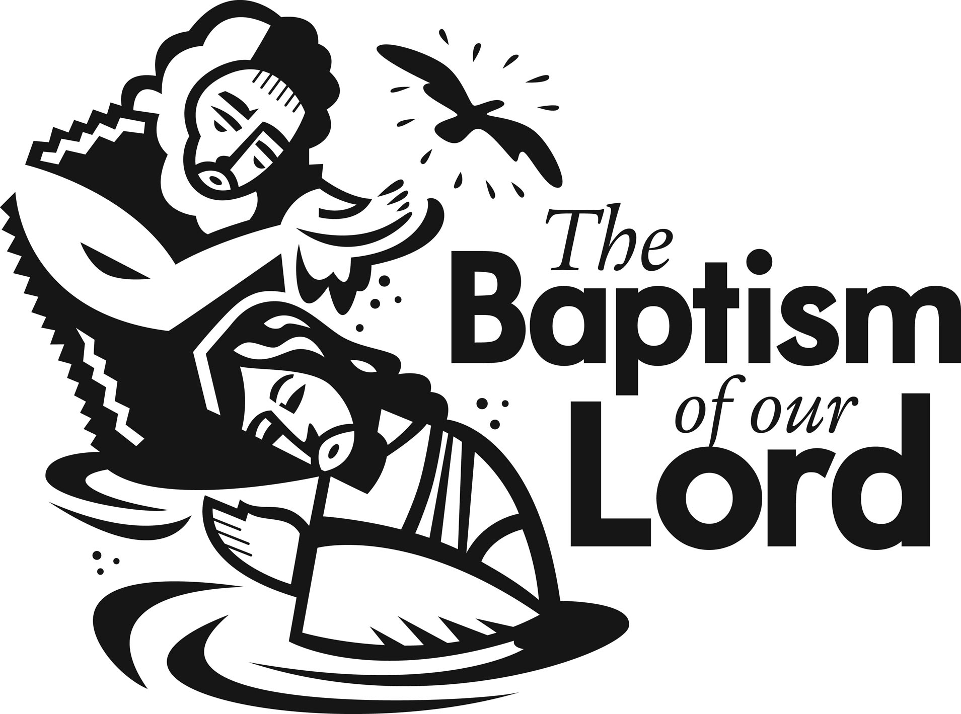

**HOLY TRINITY PARISH SOUP KITCHEN** will be held this Thursday, January 16th in our Church Hall. We welcome everyone to come and share a meal with us. Doors open at 5:00pm and close at 6:00pm. **Please share the word that all are most welcome to come.**

**THIS WEEK’S REFLECTION:** In this first week of Ordinary Time, we might find ourselves feeling a little let-down after the Christmas season, especially in parts of the world where it seems cold and dark most days. This is where we can ask for the grace to let the stories of the gospels come alive in our hearts.

The stories from Mark's gospel offer a vivid look into the life of Jesus and his followers on such a human level. Many are stories of healing and the week begins and ends with invitations from Jesus to us -- and to his disciples. To Simon Peter and Andrew, Jesus invites, “Come after me.” To the tax collector Levi he beckons, “Follow me.”

The invitation to healing we are offered can be a part of our own reflection as we begin a new year and want to somehow “fix” what is broken in us. The healing happens if we allow Jesus into our hearts and lives.

As we look at our lives we may find a loneliness or separation from people in our family or others. We have parts of our lives that are dark and embarrassing and seem unchangeable. It is into this very darkness and discomfort that Jesus is moved with pity for us, stretches out his healing hand to us and says, “I do will it. Be made clean.”

We can hear the summons to follow him as a clear and personal call to us from Jesus, the one who already knows us and our failings and yet asks us to be with him. We can hear this invitation more clearly if we can be touched with awareness of our own failings and understand more deeply how much we need a savior in our lives. It is then that our hearts are open to accept this invitation.

We can pray to Jesus this week for the strength to be healed of the patterns and habits of our lives that so often turn us away from him and ask for the grace to make a new beginning in our lives. If we can sit with our hands open in humility, we can accept that we can't do this on our own, but know in our hearts that with the help of God, nothing is impossible.