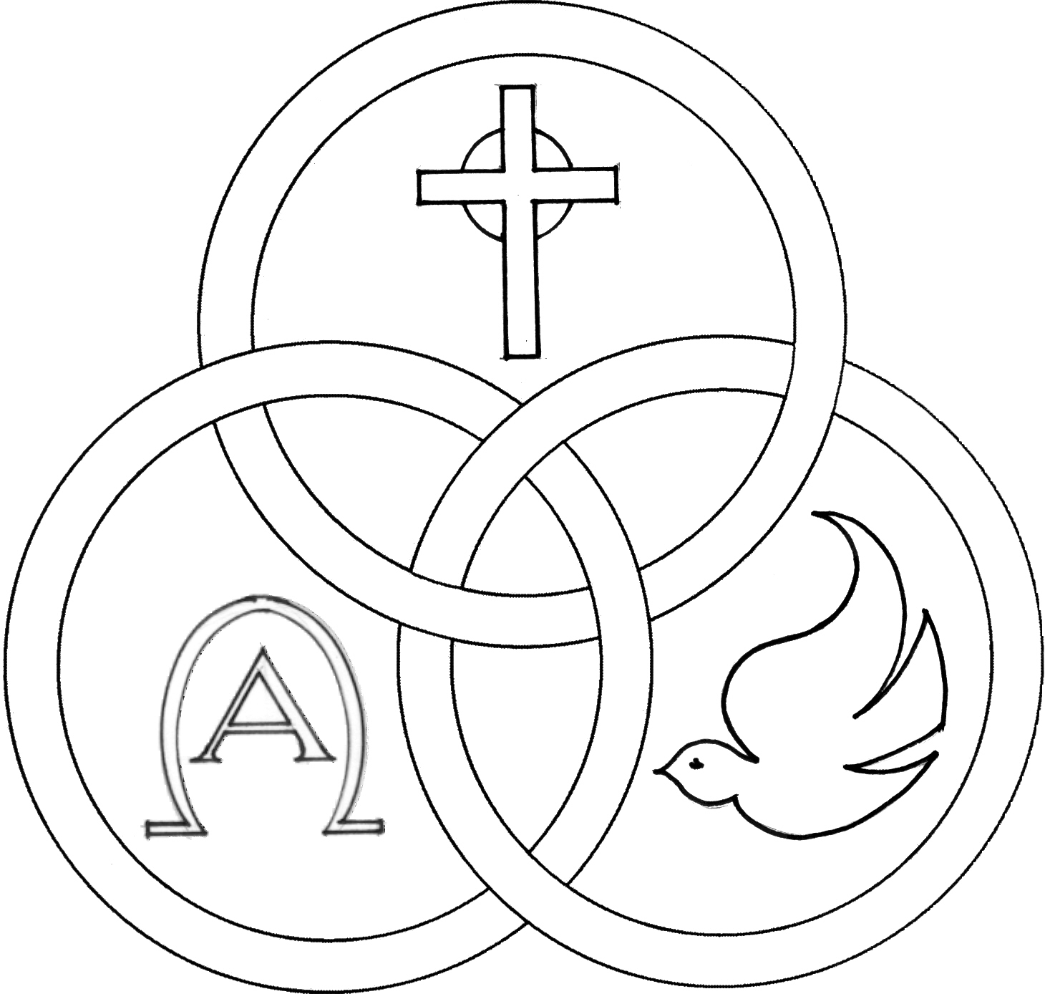**Parish of the Holy Trinity** *Roman Catholic Church*

951Stafford Road

Fall River, Massachusetts

[**www.holytrinityfallriver.com**](http://www.holytrinityfallriver.com)

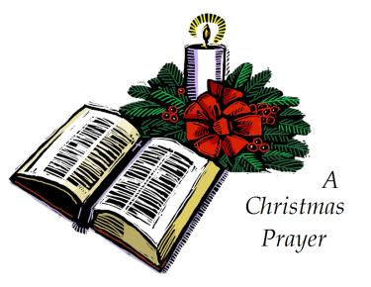

***Solemnity: Epiphany of the Lord***

**Saturday 1/4 Solemnity: Epiphany of the Lord**

4:00 pm Charles & Elaine Holland & Family

*(by Bill)*

**Sunday 1/5 Solemnity: Epiphany of the Lord**

8:30 am Odelia Andrade Birthday Remembrance *(by Family)*

10:30 am Mary Botelho

**Monday 1/6 Christmas Weekday**

8:30 am Thomas Cadima

**Tuesday** **1/7 Christmas Weekday**

8:30 am Ludgero Tavares & Maria C. Fagundes *(by Family)*

**Wednesday 1/8 Christmas Weekday**

8:30 am Maria DaPonte

**Thursday 1/9 Christmas Weekday**

8:30 am For the People *of our parish*

**Saturday 1/11 Feast: Baptism of the Lord**

**4:00 pm** Barbara & William O’Neil & Karen Costa *(by Bill)*

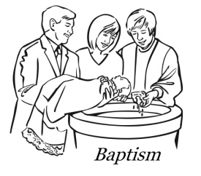**Sunday 1/12 Feast: Baptism of the Lord**

**8:30 am** James Arruda *(by Jan)*

10:30 am Antoinette Marceline *(by Family)*

ISCBC005 **Blessed Sacrament Sanctuary Lamp:**

*Given this week in memory of*

Thomas Cadima



**CSOFT003 Week of 12/22/24**

**Budget $3,625.30**

**Assessment $1,999.00**

** Week of 12/29/24**

**Budget $3,454.05**

**Fuel $1,944.30**

**300**

**FROM THE PASTOR** THANK YOU to the many people for your Christmas wishes and blessings and for the cards, gifts and goodies. They were greatly appreciated.

**THANKS TO ALL** our parishioners and friends who generously donated $7,683.00 for the Christmas collection for our parish.Thank you for your Christmas gift to our parish and thank you for your faithful support throughout the year.

**THE SECOND COLLECTION**

this weekend is to help assist our parish with snow and ice removal from all of our parking lots, walkways and sidewalks during the winter season. Thank you for all your help and support.

**PLEASE REMEMBER IN YOUR PRAYERS William Wright** whose funeral was celebrated in our parish. We extend our prayerful support to his family and friends. *May his soul and the souls of all the faithful departed, through the Mercy of God rest in peace. Amen.*

**WE WELCOME Elijah James Estrella** into our parish family through the Sacrament of Baptism. We extend our congratulations and prayerful support to his parents and family. **A very special welcome to the newest member of our parish family.**

**CHRISTMAS FLOWER MEMORIAL THANK YOU** for contributing $10,034.00 towards our Christmas Flower Memorial. Because of your generosity we were able to have some very beautiful decorations for the Christmas Season. It is a most beautiful tribute to our loved ones and friends. May the Lord grant them eternal joy and happiness!

**THE CHRISTMAS SEASON** will conclude next Sunday, January 12th, the feast of the Baptism of the Lord**.** May our celebration of Christ’s birth enable us to welcome the God who dwells among us!

**RELIGIOUS EDUCATION**

We wish all our students, their families and our Catechists all the Blessings of this Holy. Classes will resume this Sunday, January 5th 2025.



**Christmas Flower Memorial**

*Also included in loving memory of:*

Castro, Ines & Noe

Perry, Ernest J. & Evelyn

Ganczarski, Vincent

Clarke, Warren & Lois; Jeff Clarke

Shores, Stephen & Herminia

Holstein, Kathryn; Betsy Rite

Rocha, Januario

Travers, Joseph, Connie & Marybeth

Arruda, James P.

Copsetta, Frances

Gendreau, Ray; Rachel Anselmo

Woyciechowski, Irene

LeComte, Gary

Medeiros, Mariana Almeida

Medeiros, Antonio, Everest, Octavio & Jose

Medeiros, Jose Fernandes

Araujo, Alda, Daniel, Silvino

Albernaz, John; Maria Albernaz

DaSilva, Victor

DaPonte, Erneste

Bulhoes, Maria deLourdes

Senra, Joao DaPonte

Vieira, Miguel

**THANK YOU** A VERY SPECIAL THANKSto our women’s guild who has given a $3,500.00 gift to our parish. With the fundraisers our guild has been able to raise some much needed funds for our parish. We thank all the officers and members of our guild for their very generous gift, as well as, for all their hard work and effort. We are most appreciative to them for all that they do for our parish. Thanks also to the members of our parish family that have supported the activities of Holy Trinity Women’s Guild.

**THIS WEEK’S REFLECTION:** There is a very quick transition after Christmas. We move into Jesus' public life, almost completely passing over the hidden life years. Before we know it, Jesus is down at the Jordan, waiting to be baptized.

It helps to recognize this and let ourselves enter this part of the mystery of the Incarnation. We are living in the flesh each day of our lives. He came to enter this life and be with us in it. After Christmas, we have a few days to let the blessing of Christmas settle in. Now we are moving toward Ordinary Time in just one week.

Each one of us can begin our post-Christmas and the beginning of our New Year's time by staying in touch with ourselves in the flesh - as people touched by Jesus' coming. We can turn to our Lord throughout each day and have real conversations with our Savior. Over the kitchen sink, by the dishwasher, in front of the washing machine. While driving, walking, going to a meeting, returning from one.

During our preparation for Christmas we were asking the Lord to open our hearts, to let us wait with patient trust, and to come to us. During Christmas week we experienced joy and the mixed challenges of Christmas. This week we have the opportunity to have ordinary conversations with our Lord who came to be with us.

*Thank you so much, Lord, for becoming flesh for me. And, thank you for being with me now, in the midst of each day's joys and sorrows. I ask you to increase my trust in you, my desire for closeness with you and my commitment to turn to you all day long. Continue to be with me when I have to make difficult decisions, when I need extra patience and care when in challenging situations. Continue to let my heart experience the joy of Christmas this week as I see signs of your presence with me.*

When these words take on our own voice and our details, it will feel very personal. And, when we speak about our fears, our needs, when we express our gratitude and our deep desires, we are living and intimate relationship with the one who became flesh that we might never need feel alone again.

