**Parish of the Holy Trinity** *Roman Catholic Church*

951Stafford Road

Fall River, Massachusetts

[**www.holytrinityfallriver.com**](http://www.holytrinityfallriver.com)

***Second Sunday in Ordinary Time***

**Saturday 1/18 2nd Sunday in Ordinary Time**

4:00 pm Francis Arruda *(by Jan & Mike)*

**Sunday 1/19 2nd Sunday in Ordinary Time**

8:30 am Canuel & Levesque Families *(by Anna)*

10:30 am Robert Chouinard *(by Wife & Family)*

**Monday 1/20 Weekday**

8:30 am Judite Medeiros *(by Daughter)*

**Tuesday** **1/21 Agnes,** virgin & martyr

8:30 am Raymond Mello

**Wednesday 1/22 Prayer for Protection of the Unborn**

8:30 am Gertrude Tatzel *(by Family)*

**Thursday 1/23 Weekday**

8:30 am For the People *of our parish*

**Saturday 1/25 3rd Sunday in Ordinary Time**

4:00 pmEmily & Antone Pacheco *(by Jan & Mike)*

**Sunday 1/26 3rd Sunday in Ordinary Time**

8:30 amRobert Benevides *(by wife Jane)*

10:30 am Fr. Dave Andrade

ISCBC005 **Blessed Sacrament Sanctuary Lamp:**

*Given this week in memory of*

Mary Botelho

**CSOFT003 Week of 1/12/25**

**Budget $3,572.00**

**Maintenance $2,051.00**

**300**

**Yellow registration forms** are available on the tablesinside Church, near each of the entrances. Please drop them into the collection basket at Mass and **introduce yourself to Father Oliveira** after Mass or call the parish office for an appointment. **We** **hope that you feel very much at home!**

**PRAY FOR THE SICK OF OUR PARISH** and our families especially for those in hospitals, rehabilitation centers, nursing facilities and the homebound. Pray for all those who are undergoing medical treatments at this time.

**THE SECOND COLLECTION**

this weekend is to help assist our parish with the substantial fuel and heating costs that we incur during the fall and winter seasons. Thank you so very much for all your support!

**PLEASE REMEMBER IN YOUR PRAYERS Margaret Lemothe** whose funeral was celebrated in our parish. We extend our prayerful support to her family and friends. *May her soul and the souls of all the faithful departed, through the Mercy of God rest in peace. Amen.*

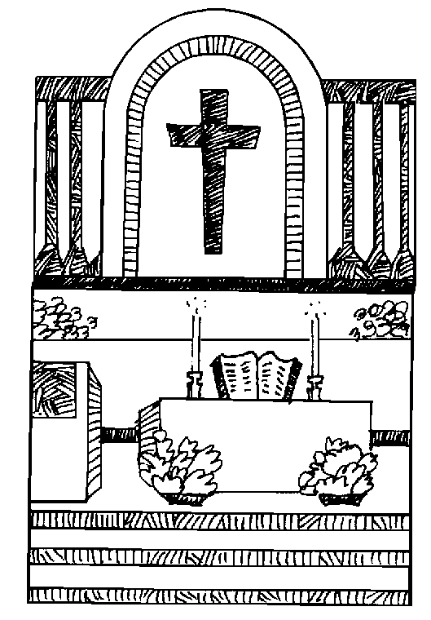**MASS FOR ALL OUR BELOVED DECEASED** Mass of Remembrance will be celebrated at the Mausoleum Chapel at Notre Dame Cemetery in Fall River on Saturday, January 25, 2025 at 9:00 am. A Mass of Remembrance will also be celebrated at Holy Name of the Sacred Heart of Jesus Church in New Bedford on Sunday January 26, 2025 at 10:00 am.

**OUR PARISH OFFICE WILL BE CLOSED THIS MONDAY,** January 20th in observance of the Martin Luther King, Jr. holiday. Our office will reopen on Tuesday January 21st.

**RELIGIOUS EDUCATION**

There will be no classes THIS Sunday, January 19th due to the Martin Luther King Holiday. Classes will resume on Sunday, January 26th.

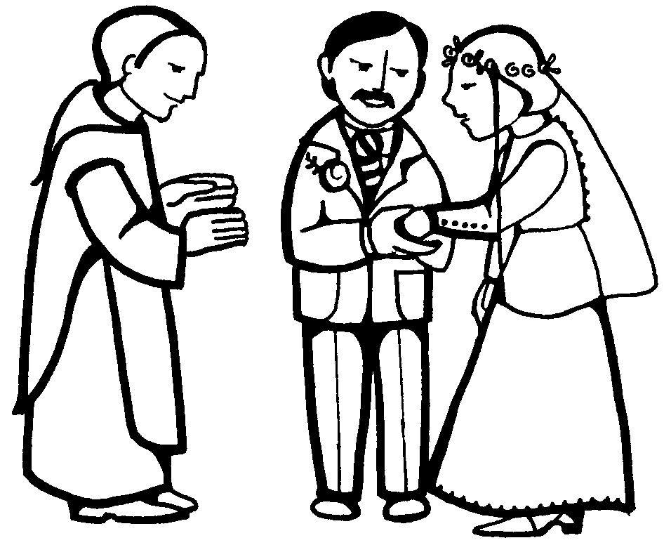**WEDDING ANNIVERSARY CELEBRATION**: A special Mass of thanksgiving will be celebrated for couples observing significant wedding anniversaries (including first year). This celebration will take place on Sunday, February 9th 2025, at 3:00 p.m. at St. Mary Cathedral in Fall River. If you would like an invitation, please let your Pastor know as soon as possible.

**CATHOLIC SCHOOL WEEK this year is the week of January 26th.** Please keep our school, teachers, staff and students in your thoughts and prayers. More information will be in upcoming bulletin announcements

**PRAY TO PROTECT HUMAN LIFE:** Life begins at conception and deserves to be protected. Sign up to pray with THOUSANDS of Catholics nationwide during the 9 Days for Life novena Thursday, January 16, 2025 – Friday January 24, 2025.

For more information, please visit: <https://www.respectlife.org/9-dayssignup>.

For information about Day for the Legal Protection of Unborn Children on Wednesday January 22nd, day of prayer, go to: [www.usccb.org/prayer-and](http://www.usccb.org/prayer-and)-worship/resources/january-22-day-ofprayer.cfm.



**THIS WEEK’S REFLECTION:** Ordinary Time is the longest Season of the Church year. Week after week, we are following the scriptures, and learning from them. It is important to focus our desires early in the day and talk with the Lord throughout the day, in the background of our busy lives. This is how we become "Contemplatives in Action" and find intimacy with God without leaving the context of the real circumstances of our lives.

Sometimes we protest: "I don't have time to pray." But if we change our focus to the moments we have free, we find ourselves surprised at the time we really do have. There are dozens of times in all of our days during which our minds are occupied with something: a song, re-playing the last event, practicing a conversation with someone, having an imaginary argument with someone, thinking through the "to do" list of the day. We can learn to fill these times with whatever we choose. If we choose to let it be about our relationship with our Lord, it transforms our lives.

It all begins with our mornings. This week, when we first get up and perhaps for a few moments while bathing or getting dressed, let's tell the Lord that our desire today is to be more conscious that everything we do this day, is in response to his call to be a disciple. Then, in those moments while driving or shopping or walking down the hall to a meeting, we can talk with God about how we are living our call in this or that activity we are engaged in. That conversation may get more detailed and specific depending on the event.

Each evening, for even a few moments, we can review our day's momentary conversations, recognizing the moments of real connection and grace and giving thanks for them, and resolving to take even greater advantage of these opportunities the next day.

*Dear Lord, at times, my heart is quite sluggish. Give me hope today. Lift my spirits and give me perspective. When I find myself stiff and inflexible, make me into a new wineskin to receive the alive, new wine with which you wish to fill me. And let me be open to your call to discipleship today. What are the opportunities to preach your Word today? Where can I drive out demons, rather than sit with their discouragement and division? Please fill my home, my workplace, my heart with your Spirit, that I might join you in bringing good news for the poor.*